The Oracle Server
The Oracle server is an object-relational database management system that provides an open, comprehensive, and integrated approach to information management. An Oracle server consists of an Oracle database and an Oracle server instance.

An Oracle Instance
Every time a database is started, a system global area (SGA) is allocated and Oracle background processes are started. The system global area is an area of memory used for database information shared by the database users. The combination of the background processes and memory buffers is called an Oracle instance.
An Oracle instance has two types of processes: user processes and Oracle processes.
- A user process executes the code of an application program (such as an Oracle Forms application) or an Oracle Tool (such as Oracle Enterprise Manager).
- Oracle processes are server processes that perform work for the user processes and background processes that perform maintenance work for the Oracle server.

The Oracle Parallel Server: Multiple Instance Systems
Some hardware architectures (for example, shared disk systems) allow multiple computers to share access to data, software, or peripheral devices. Oracle with the Parallel Server option can take advantage of such architecture by running multiple instances that share a single physical database. In appropriate applications, the Oracle Parallel Server allows access to a single database by the users on multiple machines with increased performance

Database Structure and Space Management
An Oracle database is a collection of data that is treated as a unit. The purpose of a database is to store and retrieve related information. The database has logical structures and physical structures. Because the physical and logical structures are separate, the physical storage of data can be managed without affecting the access to logical storage structures.

Logical Database Structures
The logical structures of an Oracle database include tablespaces, schema objects, data blocks, extents, and segments.

Tablespaces
A database is divided into logical storage units called tablespaces, which group related logical structures together. For example, tablespaces commonly group all of an application's objects to simplify some administrative operations.

Databases, Tablespaces, and Datafiles

Figure 1-1 Databases, Tablespaces, and Datafiles
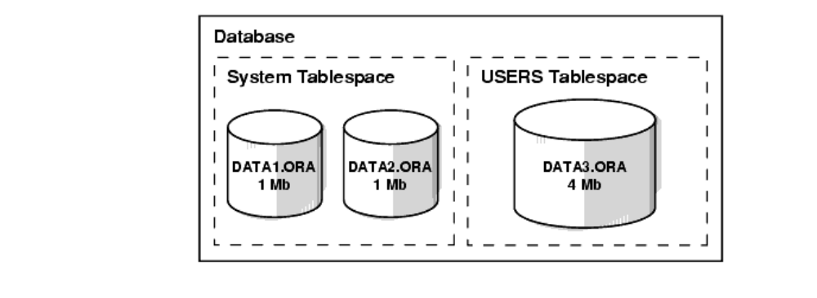
This figure illustrates the following:
- Each database is logically divided into one or more tablespaces.
- One or more datafiles are explicitly created for each tablespace to physically store the data of all logical structures in a tablespace.
- The combined size of a tablespace's datafiles is the total storage capacity of the tablespace (SYSTEM tablespace has 2 MB storage capacity while USERS tablespace has 4 MB).
- The combined storage capacity of a database's tablespaces is the total storage capacity of the database (6 MB).

Online and Offline Tablespaces
A tablespace can be online (accessible) or offline (not accessible). A tablespace is normally online so that users can access the information within the tablespace. However, sometimes a tablespace may be taken offline to make a portion of the database unavailable while allowing normal access to the remainder of the database. This makes many administrative tasks easier to perform.

Schemas and Schema Objects
A schema is a collection of database objects. Schema objects are the logical structures that directly refer to the database's data. Schema objects include such structures as tables, views, sequences, stored procedures, synonyms, indexes, clusters, and database links.

Data Blocks, Extents, and Segments
Oracle allows fine-grained control of disk space use through the logical storage structures, including data blocks, extents, and segments.

Oracle Data Blocks
At the finest level of granularity, Oracle database data is stored in data blocks. One data block corresponds to a specific number of bytes of physical database space on disk. A data block size is specified for each Oracle database when the database is created. A database uses and allocates free database space in Oracle data blocks.

Extents
The next level of logical database space is called an extent. An extent is a specific number of contiguous data blocks, obtained in a single allocation, used to store a specific type of information.

Segments
The level of logical database storage above an extent is called a segment. A segment is a set of extents allocated for a certain logical structure. For example, the different types of segments include:
data segment | Each non-clustered table has a data segment. All of the table's data is stored in the extents of its data segment. For a partitioned table, each partition has a data segment.  Each cluster has a data segment. The data of every table in the cluster is stored in the cluster's data segment.
index segment | Each index has an index segment that stores all of its data. For a partitioned index, each partition has an index segment.
rollback segment | One or more rollback segments for a database are created by the database administrator to temporarily store undo information.
The information in a rollback segment is used:
- To generate read-consistent database information
- During database recovery
- To rollback uncommitted transactions for users

temporary segment | Temporary segments are created by Oracle when a SQL statement needs a temporary work area to complete execution. When the statement finishes execution, the temporary segment's extents are returned to the system for future use.

Oracle dynamically allocates space when the existing extents of a segment become full. Therefore, when the existing extents of a segment are full, Oracle allocates another extent for that segment as needed. Because extents are allocated as needed, the extents of a segment may or may not be contiguous on disk.

Physical Database Structures
The following sections explain the physical database structures of an Oracle database, including datafiles, redo log files, and control files.

Datafiles
Every Oracle database has one or more physical datafiles. A database's datafiles contain all the database data. The data of logical database structures such as tables and indexes is physically stored in the datafiles allocated for a database.
The characteristics of datafiles are:
- A datafile can be associated with only one database.
- Datafiles can have certain characteristics set to allow them to automatically extend when the database runs out of space.
- One or more datafiles form a logical unit of database storage called a tablespace, as discussed earlier in this chapter.

The Use of Datafiles
The data in a datafile is read, as needed, during normal database operation and stored in the memory cache of Oracle. For example, assume that a user wants to access some data in a table of a database. If the requested information is not already in the memory cache for the database, it is read from the appropriate datafiles and stored in memory.
Modified or new data is not necessarily written to a datafile immediately. To reduce the amount of disk access and increase performance, data is pooled in memory and written to the appropriate datafiles all at once, as determined by the DBWn background process of Oracle.

Redo Log Files
Every Oracle database has a set of two or more redo log files. The set of redo log files for a database is collectively known as the database's redo log. A redo log is made up of redo entries (also called redo records), each of which is a group of change vectors describing a single atomic change to the database.
The primary function of the redo log is to record all changes made to data. Should a failure prevent modified data from being permanently written to the datafiles, the changes can be obtained from the redo log and work is never lost.
Redo log files are critical in protecting a database against failures. To protect against a failure involving the redo log itself, Oracle allows a multiplexed redo log so that two or more copies of the redo log can be maintained on different disks.

The Use of Redo Log Files
The information in a redo log file is used only to recover the database from a system or media failure that prevents database data from being written to a database's datafiles.
For example, if an unexpected power outage terminates database operation, data in memory cannot be written to the datafiles and the data is lost. However, any lost data can be recovered when the database is opened, after power is restored. By applying the information in the most recent redo log files to the database's datafiles, Oracle restores the database to the time at which the power failure occurred.
The process of applying the redo log during a recovery operation is called rolling forward

Control Files
Every Oracle database has a control file. A control file contains entries that specify the physical structure of the database. For example, it contains the following types of information:
- Database name
- Names and locations of datafiles and redo log files
- Time stamp of database creation
Like the redo log, Oracle allows the control file to be multiplexed for protection of the control file.

The Use of Control Files
Every time an instance of an Oracle database is started, its control file is used to identify the database and redo log files that must be opened for database operation to proceed. If the physical makeup of the database is altered (for example, a new datafile or redo log file is created), the control file is automatically modified by Oracle to reflect the change.

Data Utilities
There are three utilities for moving a subset of an Oracle database from one database to another: Export, Import, and SQL*Loader.

Export
The Export utility provides a simple way for you to transfer data objects between Oracle databases, even if they reside on platforms with different hardware and software configurations. Export extracts the object definitions and table data from an Oracle database and stores them in an Oracle binary-format Export dump file located typically on disk or tape.
Such files can then be copied via ftp or physically transported (in the case of tape) to a different site and used, with the Import utility, to transfer data between databases that are on machines not connected via a network or as backups in addition to normal backup procedures.
When you run Export against an Oracle database, it extracts objects such as tables, followed by their related objects, and then writes them to the Export dump file.

Import
The Import utility inserts the data objects extracted from one Oracle database by the Export utility into another Oracle database. Export dump files can be read only by Import.
Import reads the object definitions and table data that the Export utility extracted from an Oracle database and stored in an Oracle binary-format Export dump file located typically on disk or tape.
The Export and Import utilities can also facilitate certain aspects of Oracle Advanced Replication functionality like offline instantiation.

SQL*Loader
Export dump files can be read only by the Oracle Import utility. If you need to read load data from ASCII fixed-format or delimited files, you can use the SQL*Loader utility. SQL*Loader loads data from external files into tables in an Oracle database. SQL*Loader accepts input data in a variety of formats, can perform filtering (selectively loading records based upon their data values), and can load data into multiple Oracle database tables during the same load session.

Introduction to an Oracle Instance
Every running Oracle database is associated with an Oracle instance. When a database is started on a database server (regardless of the type of computer), Oracle allocates a memory area called the System Global Area (SGA) and starts one or more Oracle processes. This combination of the SGA and the Oracle processes is called an Oracle instance. The memory and processes of an instance manage the associated database's data efficiently and serve the one or multiple users of the database.

Figure 5-1 An Oracle Instance
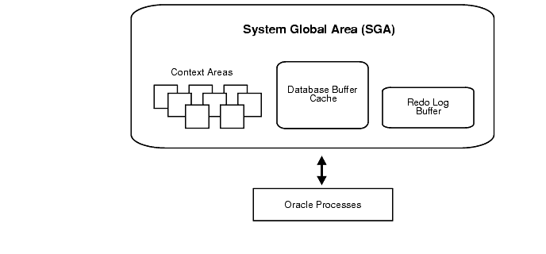

The Instance and the Database
After starting an instance, Oracle associates the instance with the specified database. This is called mounting the database. The database is then ready to be opened, which makes it accessible to authorized users.
Multiple instances can execute concurrently on the same computer, each accessing its own physical database. In clustered and massively parallel systems (MPP), the Oracle Parallel Server allows multiple instances to mount a single database.
Only the database administrator can start up an instance and open the database. If a database is open, the database administrator can shut down the database so that it is closed. When a database is closed, users cannot access the information that it contains.
Security for database startup and shutdown is controlled via connections to Oracle with administrator privileges. Normal users do not have control over the current status of an Oracle database

Memory Structure and Processes
This section discusses the memory and process structures used by an Oracle server to manage a database. Among other things, the architectural features discussed in this section provide an understanding of the capabilities of the Oracle server to support:
- Many users concurrently accessing a single database
- The high performance required by concurrent multi-user, multi-application database systems
An Oracle server uses memory structures and processes to manage and access the database. All memory structures exist in the main memory of the computers that constitute the database system.
Processes are jobs or tasks that work in the memory of these computers.

Memory Structures
Oracle creates and uses memory structures to complete several jobs. For example, memory stores program code being executed and data that is shared among users. Two basic memory structures are associated with Oracle: the system global area (which includes the database buffers, redo log buffers, and the shared pool) and the program global areas. The following subsections explain each in detail.

Figure 1-2 Memory Structures and Processes of Oracle
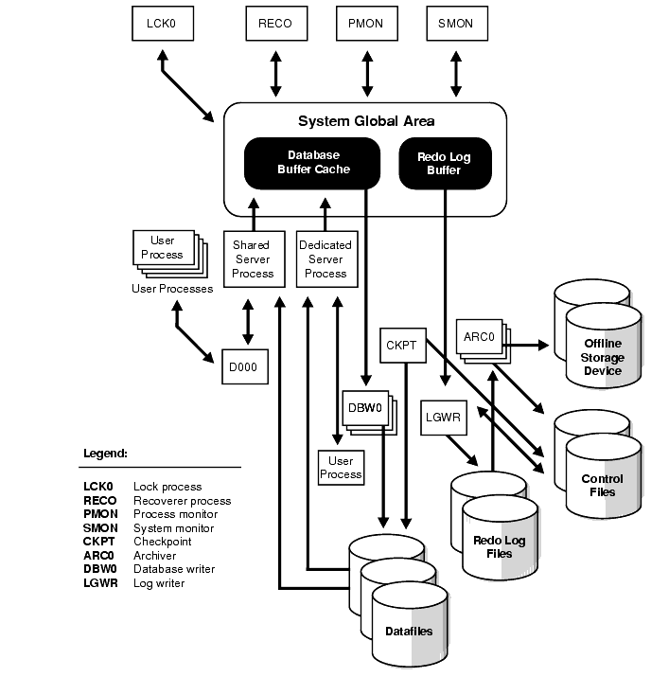

System Global Area
The System Global Area (SGA) is a shared memory region that contains data and control information for one Oracle instance. An SGA and the Oracle background processes constitute an Oracle instance.
Oracle allocates the system global area when an instance starts and deallocates it when the instance shuts down. Each instance has its own system global area.
Users currently connected to an Oracle server share the data in the system global area. For optimal performance, the entire system global area should be as large as possible (while still fitting in real memory) to store as much data in memory as possible and minimize disk I/O.
The information stored within the system global area is divided into several types of memory structures, including the database buffers, redo log buffer, and the shared pool. These areas have fixed sizes and are created during instance startup.

Database Buffer Cache
Database buffers of the system global area store the most recently used blocks of data; the set of database buffers in an instance is the database buffer cache. The buffer cache contains modified as well as unmodified blocks. Because the most recently (and often the most frequently) used data is kept in memory, less disk I/O is necessary and performance is improved.

Redo Log Buffer
The redo log buffer of the system global area stores redo entries--a log of changes made to the database. The redo entries stored in the redo log buffers are written to an online redo log file, which is used if database recovery is necessary. Its size is static.

Shared Pool
The shared pool is a portion of the system global area that contains shared memory constructs such as shared SQL areas. A shared SQL area is required to process every unique SQL statement submitted to a database. A shared SQL area contains information such as the parse tree and execution plan for the corresponding statement. A single shared SQL area is used by multiple applications that issue the same statement, leaving more shared memory for other uses

Large Pool
The large pool is an optional area in the SGA that provides large memory allocations for Oracle backup and restore operations, I/O server processes, and session memory for the multi-threaded server and Oracle XA.

Statement Handles or Cursors
A cursor is a handle (a name or pointer) for the memory associated with a specific statement. (The Oracle Call Interface, OCI, refers to these as statement handles.) Although most Oracle users rely on the automatic cursor handling of the Oracle utilities, the programmatic interfaces offer application designers more control over cursors.
For example, in precompiler application development, a cursor is a named resource available to a program and can be specifically used for the parsing of SQL statements embedded within the application. The application developer can code an application so that it controls the phases of SQL statement execution and thus improve application performance.

Program Global Area (PGA)
The Program Global Area (PGA) is a memory buffer that contains data and control information for a server process. A PGA is created by Oracle when a server process is started. The information in a PGA depends on the configuration of Oracle.

Process Architecture
A process is a "thread of control" or a mechanism in an operating system that can execute a series of steps. Some operating systems use the terms job or task. A process normally has its own private memory area in which it runs.
An Oracle server has two general types of processes: user processes and Oracle processes.

User (Client) Processes
A user process is created and maintained to execute the software code of an application program (such as a Pro*C/C++ program) or an Oracle tool (such as Oracle Enterprise Manager). The user process also manages the communication with the server processes.
User processes communicate with the server processes through the program interface, which is described in a later section.

Oracle Process Architecture
Oracle processes are called by other processes to perform functions on behalf of the invoking process. The different types of Oracle processes and their specific functions are discussed in the following sections. They include server processes and background processes.

Server Processes
Oracle creates server processes to handle requests from connected user processes. A server process is in charge of communicating with the user process and interacting with Oracle to carry out requests of the associated user process. For example, if a user queries some data that is not already in the database buffers of the system global area, the associated server process reads the proper data blocks from the datafiles into the system global area.
Oracle can be configured to vary the number of user processes per server process. In a dedicated server configuration, a server process handles requests for a single user process. A multi-threaded server configuration allows many user processes to share a small number of server processes, minimizing the number of server processes and maximizing the utilization of available system resources.
On some systems, the user and server processes are separate, while on others they are combined into a single process. If a system uses the multi-threaded server or if the user and server processes run on different machines, the user and server processes must be separate. Client/server systems separate the user and server processes and execute them on different machines.

Background Processes
Oracle creates a set of background processes for each instance. They consolidate functions that would otherwise be handled by multiple Oracle programs running for each user process. The background processes asynchronously perform I/O and monitor other Oracle processes to provide increased parallelism for better performance and reliability.
An SGA and the set of Oracle background processes constitute an Oracle instance. Each Oracle instance may use several background processes. The names of these processes are DBWn, LGWR, CKPT, SMON, PMON, ARCn, RECO, Dnnn, LCK0, SNPn, and QMNn.

Database Writer (DBWn)
The database writer writes modified blocks from the database buffer cache to the datafiles. Although one database writer process (DBW0) is sufficient for most systems, you can configure additional processes (DBW1 through DBW9) to improve write performance for a system that modifies data heavily. The initialization parameter DB_WRITER_PROCESSES specifies the number of DBWn processes.
Since Oracle uses write-ahead logging, DBWn does not need to write blocks when a transaction commits. Instead, DBWn is designed to perform batched writes with high efficiency. In the most common case, DBWn writes only when more data needs to be read into the system global area and too few database buffers are free. The least recently used data is written to the datafiles first. DBWn also performs writes for other functions such as checkpointing.

Log Writer (LGWR)
The log writer writes redo log entries to disk. Redo log entries are generated in the redo log buffer of the system global area (SGA), and LGWR writes the redo log entries sequentially into an online redo log file. If the database has a multiplexed redo log, LGWR writes the redo log entries to a group of online redo log files.

Checkpoint (CKPT)
At specific times, all modified database buffers in the system global area are written to the datafiles by DBWn; this event is called a checkpoint. The checkpoint process is responsible for signalling DBWn at checkpoints and updating all the datafiles and control files of the database to indicate the most recent checkpoint.

System Monitor (SMON)
The system monitor performs crash recovery when a failed instance starts up again. In a multiple instance system (one that uses Oracle Parallel Server), the SMON process of one instance can perform instance recovery for other instances that have failed. SMON also cleans up temporary segments that are no longer in use and recovers dead transactions skipped during crash and instance recovery because of file-read or offline errors. These transactions are eventually recovered by SMON when the tablespace or file is brought back online. SMON also coalesces free extents within the database's dictionary-managed tablespaces to make free space contiguous and easier to allocate.

Process Monitor (PMON)
The process monitor performs process recovery when a user process fails. PMON is responsible for cleaning up the cache and freeing resources that the process was using. PMON also checks on dispatcher (see below) and server processes and restarts them if they have failed.

Archiver (ARCn)
The archiver copies the online redo log files to archival storage when they are full or a log switch occurs. Although a single ARCn process (ARC0) is sufficient for most systems, you can specify up to ten ARCn processes by using the dynamic initialization parameter LOG_ARCHIVE_MAX_PROCESSES. If the workload becomes too great for the current number of ARCn processes, LGWR automatically starts another ARCn process up to the maximum of ten processes. ARCn is active only when a database is in ARCHIVELOG mode and automatic archiving is enabled.

The Redo Log
The redo log is a set of files that protect altered database data in memory that has not been written to the datafiles. The redo log can consist of two parts: the online redo log and the archived redo log.

The Online Redo Log
The online redo log is a set of two or more online redo log files that record all changes made to the database, including both uncommitted and committed changes. Redo entries are temporarily stored in redo log buffers of the system global area, and the background process LGWR writes the redo entries sequentially to an online redo log file. LGWR writes redo entries continually; it also writes a commit record every time a user process commits a transaction.
The online redo log files are used in a cyclical fashion; for example, if two files constitute the online redo log, the first file is filled, the second file is filled, the first file is reused and filled, the second file is reused and filled, and so on. Each time a file is filled, it is assigned a log sequence number to identify the set of redo entries.
To avoid losing the database due to a single point of failure, Oracle can maintain multiple sets of online redo log files. A multiplexed online redo log consists of copies of online redo log files physically located on separate disks; changes made to one member of the group are made to all members.
If a disk that contains an online redo log file fails, other copies are still intact and available to Oracle. System operation is not interrupted and the lost online redo log files can be easily recovered using an intact copy.

The Archived Redo Log
Optionally, filled online redo files can be archived before being reused, creating an archived redo log. Archived (offline) redo log files constitute the archived redo log.
The presence or absence of an archived redo log is determined by the mode that the redo log is using:
ARCHIVELOG | The filled online redo log files are archived before they are reused in the cycle.
NOARCHIVELOG | The filled online redo log files are not archived.

In ARCHIVELOG mode, the database can be completely recovered from both instance and disk failure. The database can also be backed up while it is open and available for use. However, additional administrative operations are required to maintain the archived redo log.
If the database's redo log operates in NOARCHIVELOG mode, the database can be completely recovered from instance failure but not from disk failure. Also, the database can be backed up only while it is completely closed. Because no archived redo log is created, no extra work is required by the database administrator.

Recoverer (RECO)
The recoverer is used to resolve distributed transactions that are pending due to a network or system failure in a distributed database. At timed intervals, the local RECO attempts to connect to remote databases and automatically complete the commit or rollback of the local portion of any pending distributed transactions.

Dispatcher (Dnnn)
Dispatchers are optional background processes, present only when a multi-threaded server configuration is used. At least one dispatcher process is created for every communication protocol in use (D000, . . ., Dnnn). Each dispatcher process is responsible for routing requests from connected user processes to available shared server processes and returning the responses back to the appropriate user processes.

Lock (LCK0)
The lock process (LCK0) is used for inter-instance locking in the Oracle Parallel Server.

Job Queue (SNPn)
In a distributed database configuration, up to thirty-six job queue processes (SNP0, ..., SNP9, SNPA, ..., SNPZ) can automatically refresh table snapshots. These processes wake up periodically and refresh any snapshots that are scheduled to be automatically refreshed. If more than one job queue process is used, the processes share the task of refreshing snapshots. These processes also execute job requests created by the DBMS_JOB package and propagate queued messages to queues on other databases.

Queue Monitor (QMNn)
The queue monitor(s) are optional background processes that monitor the message queues for Oracle Advanced Queuing (Oracle AQ). You can configure up to ten queue monitor processes

Connecting with Administrator Privileges
Database startup and shutdown are powerful administrative options and are restricted to users who connect to Oracle with administrator privileges. Depending on the operating system, one of the following conditions establishes administrator privileges for a user:
- The user's operating system privileges allow him or her to connect using administrator privileges.
- The user is granted the SYSDBA or SYSOPER privileges and the database uses password files to authenticate database administrators.
- The database has a password for the INTERNAL login, and the user knows the password.
When you connect with SYSDBA or SYSOPER privileges, you are placed in the schema owned by SYS. SYSOPER privileges are a subset of SYSDBA privileges.

Parameter Files
To start an instance, Oracle must read a parameter file--a text file containing a list of configuration parameters (initialization parameters) for that instance and database. You set these parameters to particular values to initialize many of the memory and process settings of an Oracle instance. Most initialization parameters belong to one of the following groups:
- Parameters that name things (such as files)
- Parameters that set limits (such as maximums)
- Parameters that affect capacity (such as the size of the SGA), which are called variable parameters
Among other things, the initialization parameters tell Oracle:
- The name of the database for which to start up an instance
- How much memory to use for memory structures in the SGA
- What to do with filled online redo log files
- The names and locations of the database's control files
- The names of private rollback segments in the database

An Example of a Parameter File
The following is an example of a typical parameter file:
db_block_buffers = 550
db_name = ORA8PROD
db_domain = US.ACME.COM
#
license_max_users = 64
#
control_files = filename1, filename2
#
log_archive_dest = c:\logarch
log_archive_format = arch%S.ora
log_archive_start = TRUE
log_buffer = 64512
log_checkpoint_interval = 256000
# rollback_segments = rs_one, rs_two

